LAB TITLE

**Submitted by:**

|  |  |
| --- | --- |
| **Name** | **ID** |
| Mariam ahmed | 96722 |

**Submitted to:**

Ms. Donthi Sankalpa

Lab Instructor

American University of Sharjah

College of Engineering

**Submitted on:**

Date

Abstract

In this lab, we will analyse addition and subtraction on the ELVIS Board. We will also build an adder and subtractor and then implement it onto the board.

Introduction

In this lab we will Boolean arithmetic expressions using digital circuits. We will also develop both adder and subtractor circuits to get an output. As usual, we have used the NI ELVIS Board and connectors to assemble out circuit. We will also use ICs to assemble our circuit along with the usual other components.

Theoretical Background

In this lab, we have used our knowledge of the software Logisim to simulate our circuit. We needed to know how to add and subtract binary numbers and check our answers on Logisim. We were also required to know how to implement circuits on the ELVIS Board to check our results. Truth tables and Karnaugh Maps are also required for the lab.

Experimental work, Results and Discussion

This section will include the direct answers to the questions given in the lab script as well as any screenshots, tables or results required for the experimental work. These requirements will be stated by the lab instructor and on the lab script. This section should also include an over all discussion of the results with any unique findings if needed.

Q1)

|  |  |  |  |  |  |  |  |
| --- | --- | --- | --- | --- | --- | --- | --- |
| A | B | C | D | W | X | Y | Z |
| **0** | **0** | **0** | **0** | 0 | 0 | 0 | 0 |
| **0** | **0** | **0** | **1** | 1 | 1 | 1 | 1 |
| **0** | **0** | **1** | **0** | 1 | 1 | 1 | 0 |
| **0** | **0** | **1** | **1** | 1 | 1 | 0 | 1 |
| **0** | **1** | **0** | **0** | 1 | 1 | 0 | 0 |
| **0** | **1** | **0** | **1** | 1 | 0 | 1 | 1 |
| **0** | **1** | **1** | **0** | 1 | 0 | 1 | 0 |
| **0** | **1** | **1** | **1** | 1 | 0 | 0 | 1 |
| **1** | **0** | **0** | **0** | 1 | 0 | 0 | 0 |
| **1** | **0** | **0** | **1** | 0 | 1 | 1 | 1 |
| **1** | **0** | **1** | **0** | 0 | 1 | 1 | 0 |
| **1** | **0** | **1** | **1** | 0 | 1 | 0 | 1 |
| **1** | **1** | **0** | **0** | 1 | 1 | 0 | 0 |
| **1** | **1** | **0** | **1** | 0 | 0 | 1 | 1 |
| **1** | **1** | **1** | **0** | 0 | 0 | 1 | 0 |
| **1** | **1** | **1** | **1** | 0 | 0 | 0 | 1 |

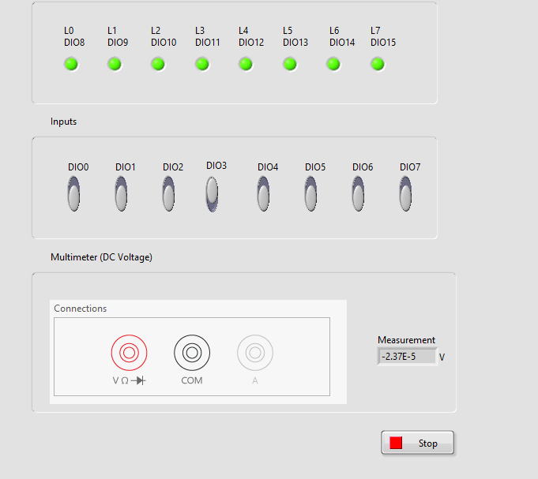

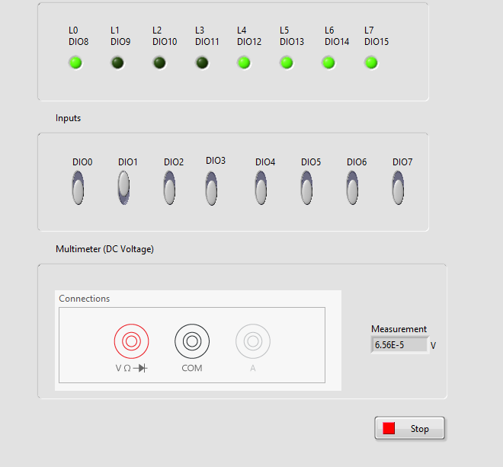

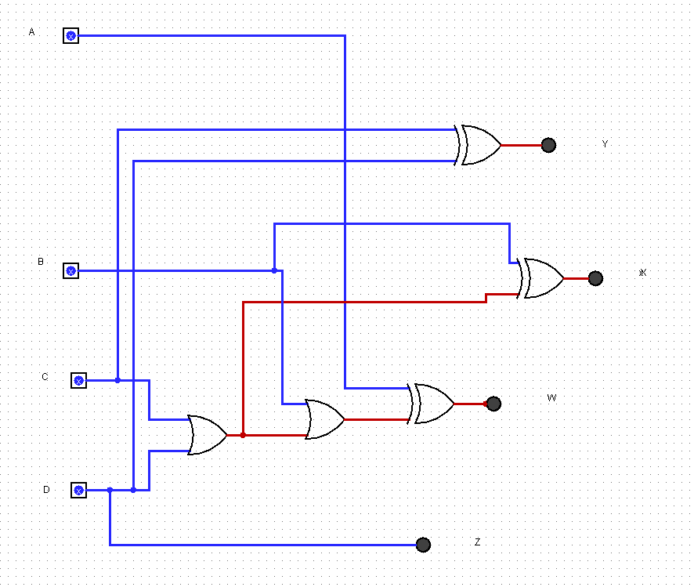

Conclusion

This section should conclude the report by re-iterating what all has been done and what you have achieved.